High-Level Design
Project 2
Upload EOD Transactions files into System

Infrastructure Overview:
- AWS S3: Used to store incoming transaction files.
- AWS Lambda: Responsible for processing and posting transactions.
- DynamoDB: Stores the Account Master and Source System Master data.
- AWS Glue: Optional, can be used for data transformations if required.

Infrastructure Setup Block Diagram:
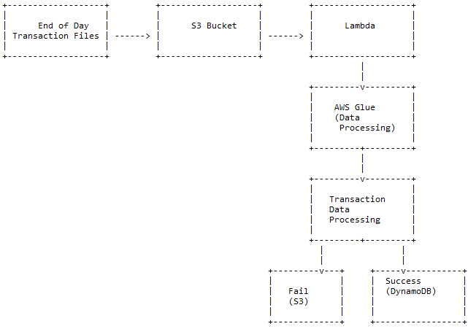
System Workflow:
- The system will receive two types of files: Parquet and Avro.
- Each file contains transaction data from a satellite system.
- The files will be uploaded to an S3 bucket.
- AWS Lambda will be triggered by the arrival of new files in the S3 bucket.
- Lambda will read the file, process the data, and generate ledger transactions.
- For each transaction, three separate entries will be posted to the Transaction table.
- Transaction amounts will be credited to the appropriate accounts (e.g., "Product Sale," "Value Added Tax," "Excise Duty," "Custom Duty").
- If a transaction fails, a separate file containing failed records will be created for reloading purposes.

Account Master Table (DynamoDB):
- Table Name: acct_master
- Columns: acc_no (Text, Unique alphanumeric), acc_name (Text), acc_desc (Text), acc_type (Text, values: I, E, A, L)

Transaction Table (DynamoDB):
- Table Name: ledger_txn
- Columns: txn_id (Integer, sequential auto-generated), voucher_code (Char(10), unique), txn_type (Char(1), values: D, C),
- txn_date (Date), acc_no (Foreign Key from acct_master), txn_amt (Numeric(11.2)), source_system_id (Integer, values: 1, 2),
- source_system_txn_id (Varchar(50))

Source System Master Table (DynamoDB):
- Table Name: src_sys_mst
- Columns: system_id (Integer, sequential auto-generated), system_name (Varchar(30))

Data Processing Block Diagram:
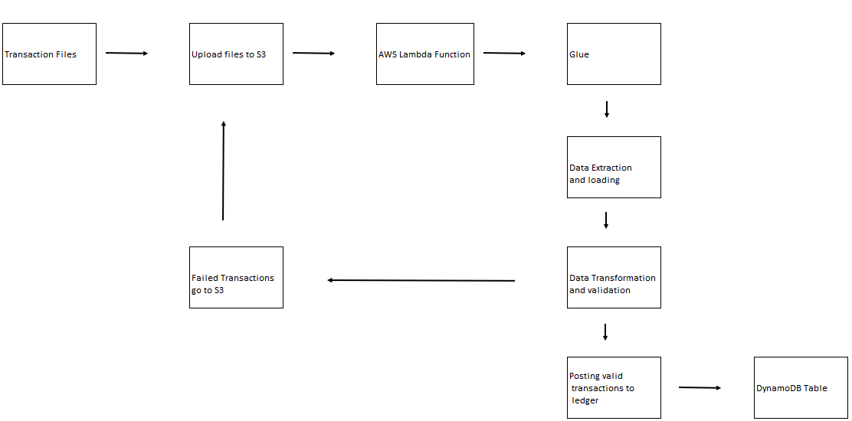

Processing Steps:
- For Parquet Files:
- Read the Parquet file from the S3 bucket.
- Extract the necessary fields (trnrefid, code, tdate, trn_amount, vat, excise_duty).
- Generate voucher code from trnrefid.
- Create three separate transaction entries for each transaction:
- Credit "Product Sale" with trn_amount.
- Credit "Value Added Tax" with vat.
- Credit "Excise Duty" with excise_duty.
- Validate the transaction date to ensure it's not a future date.
- Post the transactions to the ledger_txn table.
- If any transaction fails, create a separate file for failed records.
- For Avro Files:
- Read the Avro file from the S3 bucket.
- Extract the necessary fields (Tran_ref_id, Transaction_dt, amt, gst, custom_duty).
- Generate voucher code from Tran_ref_id.
- Create three separate transaction entries for each transaction:
- Credit "Product Sale" with amt.
- Credit an appropriate account (not specified in the requirements) with gst.
- Credit "Custom Duty" with custom_duty.
- Validate the transaction date to ensure it's not a future date.
- Post the transactions to the ledger_txn table.
- If any transaction fails, create a separate file for failed records.

Automation Considerations:
- Set up AWS CloudWatch Events to trigger the Lambda function at the end of each day when new files arrive in the S3 bucket.
- Configure Lambda to handle file processing and posting of transactions automatically.
- Schedule periodic checks for failed transactions and reload the data if needed.

This HLD provides a high-level overview of the system design based on the given requirements. It's important to consider additional factors, such as security, performance optimization, and scalability, when implementing the system in a production environment.

